The Postcolonial Feminist Critique of the UN 17 SDG’s, particularly Goal 16: Peace, Justice and Strong Institutions

David M. Boje Nov 4 2018

Goal 16: Peace, Justice, and Strong Institutions. This is our topic in the leadership and society course on Nov 5 2018. The #16 grand narrative starts out with an appeal to the situation of increasingly divided world, with endless cycles of sexual violence, crime and exploitation. The key characters are the 10 million stateless people, 20 people every minute being displaced around the globe, and the $1.26 Trillion economic cost of corruption, bribery, theft, and taxation. Violence becomes the key issue with 43% of people 10 to 29 years old experiencing it, and children being 1/3rd of 8,132 reported human trafficking victims. It’s all about the 338,594 comes against women each year, and 1,300 people killed in interpersonal conflicts each day, which is 9 times more than open warfare.

What is missing is the postcolonial critique of UN SDG #16. We in the US are part of a white supremacy with three key pillars that explain the root causes of the alarming goal #16 statistics. I therefore want to uncover the postcolonial effects of this logic of supremacy. It is not just the US. This is an issue of the global northern peoples privileging a universalism logic of northern values, marking southern people as uncivilized. The problem in the US is the normative values are white supremacy. There is in the US an organized structure of violence and fear in a grand narrative that demonized the non-white Other. This is a process known as ‘Othering’ in a binary, between we the civilized, and those others, uncivilized. The Othering is not just a black/white binary, but becomes a hierarchy of racial peoples, where one’s location in the pecking order, privileges civilized, over the next lower rung of less civilized. The hierarchical racial narrative is fused with a patriarchal gender privilege narrative.
While the accomplishments of the UN SDG’s are amazing, we have to push ahead to deal with root causes, or we will only treat the symptoms and not the underlying structural problems. Historically, the UN had 8 Millennial Development Goals that by 2015, had failed. The post-2015 17 UN SGG’s are a big improvement, but do not get us all the way to Peace Justice and Strong Institutions (Goal #16). We have to therefore address the ways the violence, injustice, and weak institutions are resultant of deeper problematic. Namely a white supremacy morphed into hierarchical racism. The work of Andrea Smith, on three pillars of white supremacy, its summary, is included below.
In my own book (Boje, in press, There is no Planet B), I explore 10 myths of (neoliberal) global capitalism that need deconstruction so we can get at the ways growthmania and greed for planetary resources are resulting in Sixth Extinction. this is a runaway Carboniferous Capitalism (as Lewis Mumford, 1934 calls it). The transition to post-Carbon capitalism is so slow going, and most of humanity will die off. In the meantime there are lifeboats for the rich (McMansions, billionaire estates), and increasing wealth concentration resulting is less and less for everyone else. In the book, I develop my own Margarita Glass visual illustration.

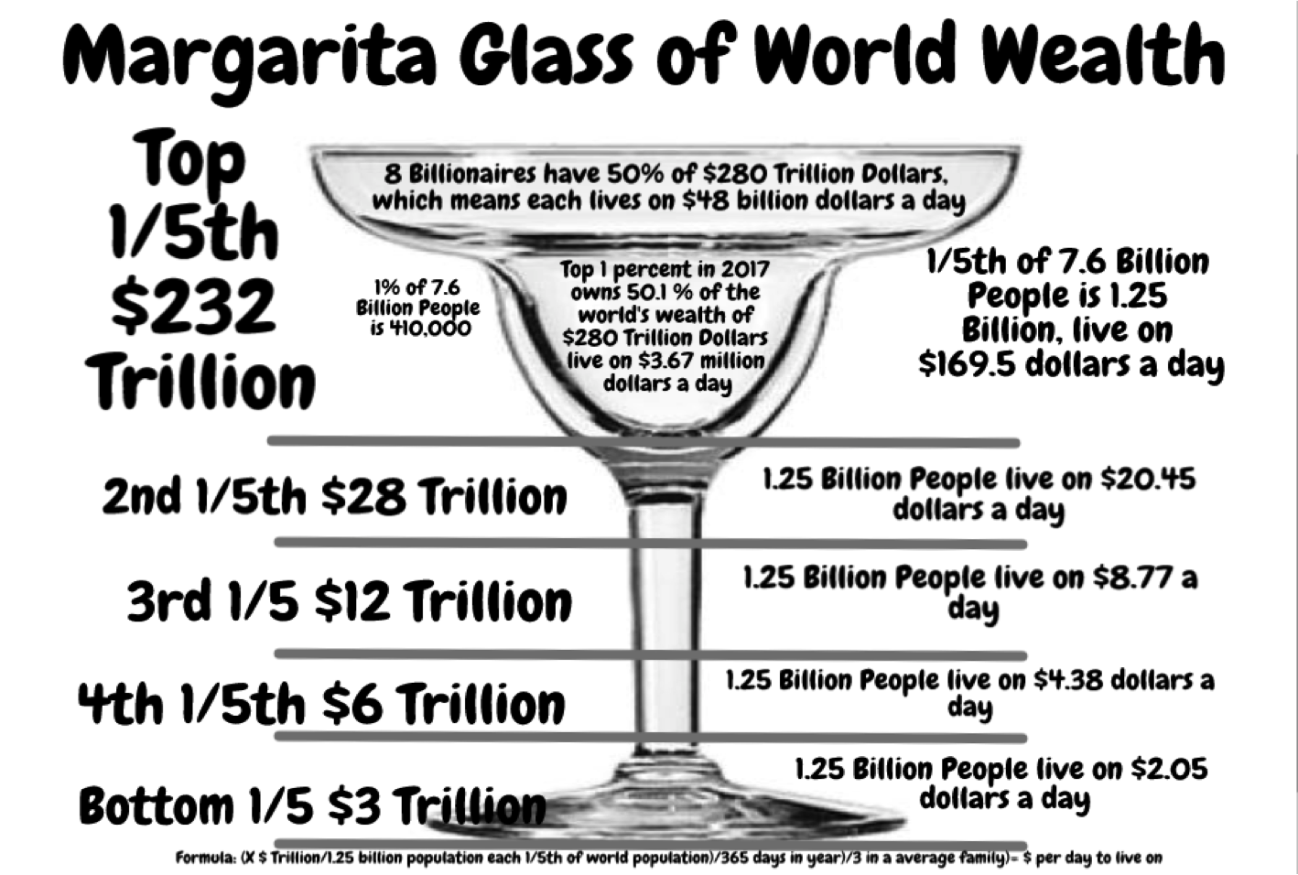

Figure 1: Boje’s Margarita Glass of Wealth Concentration into the Hands of the Haves at the Expense of the Have Nots (Boje, in press).

This concentration of wealth is accelerating the depletion of planetary resources past the limits of earth’s carrying capacity. We already have peak oil and peak water, with peak food, a few years away. The effects of climate change are all around us, but people are clinging to ‘business-as-usual’ and ‘global leadership-as-usual.’ The antenarrative future coming into being could be averted, but the time to do so is running out. The first world (northern) economies depending upon the third world (southern) economies to be poor, so that natural resources and cheap (female & child) labor can be continue to be appropriated. That is the basis of colonialism, or neocolonialism, and postcolonialism arguments. Yet, there is another root cause, the racial and gender inequalities that are being exploited in the North-South exploitation relation. And, there is a need to look self-reflexively at the violence and injustice and weak institutions, and strange leadership in US society. Keep in mind that as the Sixth Extinction intensifies and the fossil fuel peak and water peak are passed (already there, yikes), then it is anticipated that white supremacy, and blaming immigrants displaced by climate change, and North/South colonialism —> will result in less peace, less justice, and less strong institutions (Goal #16). While cooperation for simplicity and zero growth, it is unlikely to play out in an equitable manner: the haves will take more and more, and the have nots will have less and less to live on. Here is a typical trend line.

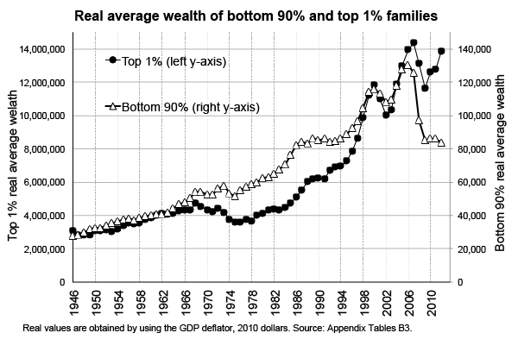
Figure 2: The Growing Gap between Haves and Have-nots in the US (source: https://voxeu.org/sites/default/files/saezfig3.png and https://voxeu.org/article/exploding-wealth-inequality-united-states)

The gap between haves and have-nots is widening in the US, and between the North and the South nations. At issue, for me, is the relation between Western Ways of Knowing (WWOK) of Eurocentric and US-centric logics of growthmania and greed, and Indigenous Ways of Knowing (IWOK) that have some sense of growth and greed limits (or did at one time). My concern is the new UN SDG’s of post-2015 have failed to address the effects of he neoliberal global capitalism system in Sixth Extinction, and ignored how the haves and have-nots, both have a death grip on the lifestyle of ‘business-as-usual’ even though its clear that that life style won’t be widely available for all, and the peace, justice, and strong institutions (Gaol #16) will be in short supply. And beneath it all is the narrative that growth will continue, technology will save us, and the civilized world will conquer the uncivilized, ‘Other’ to bring about world peace and justice. The logic is flawed. The gap of the haves and have-nots widens as does the racial prejudice and gender inequality. A fourth of the world live on a$2.05 a day, another 1.25 billion people live on $4.38 a day, etc., and at the top are 8 multi-billionaires who have amassed 50% of the $232 Trillion total wealth (see Margareta Glass visual, above). This is not a way to avert the coming 6th Extinction die off of biodiversity, including the death of most humanity. Those life boats for the rich and famous, won’t be afloat for too long. The apocalyptic movies from Mad Max and Bladerunner, to the Zombie movies point to likely scenario. If only we could move past patriarchy and racism.
IWOK has choice-making capactity by challenging dominant WWOK- Carboniferous narratives with a counternarrative of the aliveness of water, its elemental constitution of Earth ecosystem, and water spiritual ecology. In Uisge, the water horse is a dangerous wspirt. In Irish AUghisky, water spirit is prominat. IN Welsh lak, Gwragedd Annwan is a water fairy. In Kelpi, the water horse has be part of mythology, the tangie in Orkney and Shetland (source see Wikipedia, water spirit). In Christianity, “WATERSPIRIT is a center of ecology and spirituality that informs, inspires, and enables all people to deepen their consciousness of the sacredness and interdependence of all creation with a focus on water as critical in sustaining all life” (Sisters of St. Joseph Peace).

Part IL Three pillars of White Supremacy by Andrea Smith (chap 6), accessed Nov 4 2018 at https://www.pym.org/annual-sessions/wp-content/uploads/sites/7/2017/06/Smith_Heteropatriarchy_3_Pillars_of_White_Supremacy.pdf See Smith (2016) in references.

There are communities of people oppressed by three pillars of white supremacy (Smith, 2016) is about women of color: black women, Arab/Muslim women, Latina women, Native women, and Asian women.

Pillar 1: Slavery/Capitalism
Pillar 2: Genocide/Capitalism
Pillar 3: Orientalism/War

Pillar 1: Slavery/Capitalism
In white supremacy black people are enslavable, nothing more than property of slavability. This is seen in the current prison-industrial complex logic, and in sharecropping where one’s own personhood becomes a commodity to sell in the labor market whose profits go to someone else. Racial hierarchy of slavery is a part of commodification capitalism. Slavery people are no reenslaved in the US Prison system. I did some inquiry into the US’s own peaceful, injustice, and weak institutions. A prime example is the US incarceration rates of females and racial minorities. It replicates not just white/black male/female prejudices, but a whole racial/gendered hierarchical pecking order.
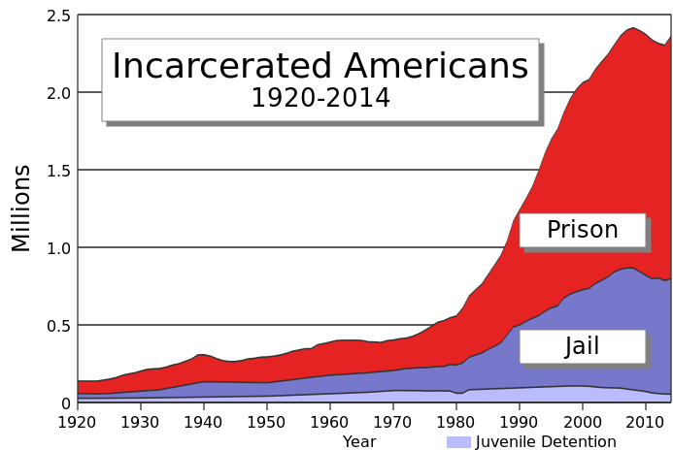
Figure 3: Incarcerated Americans 1920-2014 (Source Wikipedia US prisons)

US has largest prison population in the entire world (2,220,300 adults in prisons and county jails)and highest per-capita incarceration rate (655 per 100,000. While debtor’s prison no longer exists people can still be jailed for debt, and jails are warehouses for the poor and mentally ill and the addicted without capacity to post bail. In US there is falling crime rate, but increased mass incarceration. US prison population quadrupled since 1980, in the mandatory sentencing of War on Drugs. 27% of federal prison population are non-US (noncitizen).
There is even larger number of some 7 million people on probation or prison/jail or parole. In the US there are 1.2 million violent crimes a year, and 10.7 million arrests (not including traffic violations), and 2.3 million people incarcerated in 2016. Violent crime did not quadruple the prison/jail population, rather it was public policy of mandatory minimum sentences (three strikes), War on Drugs, and increasing racial disproportions among arrestees. Recidivisms 67.5% rearrested within 3 years, and 51.8% back in prison. US has highest incarceration rate (655 per 100,000) in the world). Canada is 114, England/Wales 146, Australia 160, and Greece 89, Netherlands 69, and Japan only 48 per 100,000.

2010. Inmates in adult facilities, by race and ethnicity. Jails, and state and federal prisons.^{[56]}
Race, ethnicity | % of US population | % of U.S.  incarcerated population | National incarceration rate  (per 100,000 of all ages)
White (non-Hispanic) | 64 | 39 | 450 per 100,000
Hispanic | 16 | 19 | 831 per 100,000
Black | 13 | 40 | 2,306 per 100,000

If there were racial equality, Whites would be 64% of prison population, and Blacks only 13%. White Females are 49% of prison population (51 per 1000,00), black females 22% (113 per 100,000) is 2x the rate of white females. By age 18 30% of black males, 26% of Hispanic males, and 22% of white males have been arrested. By age 23, 49% of black males, 44% of Hispanic males, and 38% of white males have been arrested
According to Attorney Antonio Moore in his Huffington Post article, "there are more African American men incarcerated in the U.S. than the total prison populations in India, Argentina, Canada, Lebanon, Japan, Germany, Finland, Israel and England combined."
LGBT adults are disproportionately more likely to in criminal justice system 16% compared to 2.7% of all adults.There is a ‘school-to-prison’ pipeline where students out of the classroom have high probability of entering the prison system. At issue, zero-tolerance policies for student misbehavior put students on prison track, and student drops out, gets low pay job. Black students suspended at double the rate of white students in a Maryland study. California has highest overcrowding rate of US prisons. Half of people in prison are there for non-violent and victimless crimes, 20% for drug offenses. Human Rights Watch says high rates of incarceration wreaks havoc on individuals, families and communities, sapping strength of nation as a whole.
The neoliberal globalism ideology is a root cause of high incarceration rates, since prison system has been developed to respond to urban crisis, and prisons for profit, and punishment by incarceration, is a means of responding to poor and mentally ill and immigration, and war on drugs

Pillar 2: Genocide/Capitalism

The logic of genocide disappears indigenous peoples. Logic of genocide is about non-indigenous peoples claiming the land, recourses, and evening the spirituality of IWOK. Native people are a permanent “present absences” in the US colonial imagination (see Kate Shanley). Playing dead, is a way not to remind whites of the repressive mechanism performed by narrative of manifest destiny. Non-Indian people are playing Indian, to effect a physical and psychological removal of ‘real’ Indians, while claiming ‘love of Indians’ but its actually part of ‘Indian hating. Why else would non-Native people play Indian, appropriate spirituality from rightfully IWOK peoples? I wrote about the extensive genocide of Native Americans and Native Mexicans in my 2001 book.

Pillar 3: Orientalism/War

Orientalism (Edward Said): West defines itself as superior civilization by constructing itself in opposition to exotic, inferior Orient. Orientalism makes certain peoples as inferior, and as threat too wellbeing of Empire, and therefore justifying US being in constant state of war to protect itself. This Orientalism term also applies to Arab Americans singled out in ‘war on terror.’ Orientalism allows US to defend its logics of slavery and genocide PILLARS, so narrative is to stay “strong enough” to fight constant wars. US is not at war, the US is war (says Sora Han, p. 69).
In sum the system of white supremacy is still in place in the US It is a logic, not just a racial dynamic. We fail to understand the racial logic of Orientalism in operation with Latino and Arabs, as a racial hierarchy that privileges one race over another race. You can be assimilated, but are still marked as a perpetual foreign threat to the US world order. Non-Native people are promised to be able to join the global colonial project, by settling indigenous lands. Non-Black peoples are permitted if they comply, they will not be at the bottom of the racial hierarchy. Black, Native, Nation, and Asian people are promised they will economically and political advance if they join US wars to spread ‘democracy’ globally. There have been genocidal practices committed by the US government. The genocide against indigenous people.
The white supremacy logic of heteropatriarchy is replaced by multicultural representation, to be included in logics of slavery, genocide, and Orientalism based upon hierarchical binaries.
Recommend students read up on Critical Race Theory (CRT) (Hawkesworth, 2010; McCoy & Rodricks, 2015; ; Matsuda, Lawrence, Delgado, & Crenshaw, 1993). There is more going on than the black/white binary files to include experiences of other peoples of color (Indians, Asian, Latinos do exist). “‘Whiteness’ operates differently under a logic of genocide than it does form a logic of slavery”.
Welcome to Heteropatriarchy. Heteropatriarchy is the building block of US global empire. Chuck Colson, for example, equates family as natural moral order, the heteropatriarchchal family. Colson then turns to radical Islamists seeing American women abusing Muslim men in Abu Ghrib prison, and same sex marriage, code for white, patriarchal, middle class, family ideal as naturalized hierarchy of genders as nation state model.
Part II: Water Paradigm Shift
It will take a fundamental paradigm shift for humanity to avoid the Sixth Extinction. Here I will develop a ‘water storytelling’ as one life element of that paradigm shift. In water storytelling there is a collision of Carboniferous Capitalism dominant narrative of water as commodity traded in global markets, and a much weaker Ecologically Balanced Posthumanism where water is part of ‘spiritual ecology’ (Rosile, 2016; Humphries, 2001; Pepion, 2016; Little Bear, 2000; Cajete, 1999, 2000, 2015; Deloria & Wildcat, 2001; Smith, L. 1999/2000; Smith, L. 2003; Smith, GH, 2003, Smith, GH, 2017; Hoskins & Jones, 2017). Western Ways of Knowing (WWOK) and Indigenous Ways of Knowing (IWOK) the dialectic collision of water capitalism narrative with spiritual ecology of water. IWOK and WWOK are the two faces of Janus, facing in opposite directions, without a plane of existence between them (Bakhtin, 1993: 2). IWOK looks at the “never-repeatable uniqueness of actually lived and experienced life” and WWOK at the “objective unity of ta domain of culture” that is increasingly virtualizing itself. Deloria and Wildcat (2001) put IWOK this way: “Our continued existence as part of the biology of the planet is inextricably bound up with the existence and welfare of the other living beings and places of the earth: beings and places understood as persons possessing power, not objects” (Wildcat in Deloria & Wildcat, 2001: 13). WWOK is a spatialization of the concrete facts in numeric water narratives, such as how our body of 37.2 trillion living cells is 2/3rds water in those cells and other 1/3rd is water our cells swim within, and how our body is 75% water as infant and 60 to 65% water as we become adults, or how water is 75% of the earth’s surface, but 2.5 is fresh water, and 97% of water on earth is saline, and undrinkable by humans. In WWOK water will become commodity and the biggest corporate revenues in our water future. IWOK, by contrast, is a counternarrative about water aliveness, water spirituality, etc. As example of WWOK, Block and Nelson’s (2015), are in favor of ‘Water Capitalism’, saying it means market efficiency by treating water as “private property for oceans, lakes, rives, and aquifers… to be owned they same way one owns “pizza, shoes, and cows” (Block & Nelson, 2015: 24). As example of IWOK, Kaupapa Māori is an IWOK storytelling paradigm that has emerged in the work of Linda and Graham Smith to compete with the WWOK narratology paradigms.
In New Zealand they are making space for spiritual living waters, in a new eco-philosophy. For 140 years, the local Māori tribe of Whanganui in the North Island has fought for the recognition of their river to have the same legal rights as a human being. The Whanganui River can go to court, own property, and as the tribe says, “I am the river, the river is me.” Water is a living entity. The Whanganui tribe considers the river to be an ancestor. Te Awa Tupua now has its own legal identity. Eight tribes worked to get Mount Taranaki granted the legal rights of a person. Te Urewera is a forest hill that is now granted the legal status of person in New Zealand. Next is an excerpt from a paper I am presenting at the 8th annual Quantum Storytelling conference in Las Cruces, New Mexico, in December 2018 (Boje, 2018)”
“What if we in New Mexico worked to declare Organ Mountains, its waters and forest, the Rio Grande River, and all its aquifers the legal right of a person? Water quality is getting worse and water itself scarce. Water is its own aliveness. What if the ‘living whole’ of all water had its own rights and autonomy as a person? It would mean that we don’t treat water, mountain, or forest as a legal property of humans. “Water is a taonga of huge importance to Iwi and enhancing the healthier and wellbeing of our waterways is a priority for many Iwi”, wrote Mike Grace Māori liaison in 2010” (Boje, 2018).
How would we affect a water paradigm shift? I believe it starts with water storytelling. Storytelling is more than WWOK narrative-counternarrative dialectics. Storytelling is also IWOK living story webs of ecology aliveness. And, for me, storytelling has important ‘antenarrative’ processes, antecedent to both narrative-counternarrative and story-counterstory. In particular the before, between, beneath, becoming, and the bets on the future of all species, come into play in ‘water storytelling.’
As an assistant professor at UCLA, I became interested in large system transorganizational development (TD) networking, defined as planned change in the collective relationships of a variety of stakeholders to accomplish something beyond the capability of any single organization or individual (Culbert et. al., 1972). I came up with an intervention approach called ICEND (Boje, 1979, 1981, 1982; Boje & Wolfe, 1989; Boje, 1997; 1999a to e):
I - Interactive - Share stories around issues
C- Communicative - Stories of the collective
E-Experiential Immersion in Aliveness Stories
N-Network
D-Development in internal problem solving network cycle to produce extended network involvement cycle

Here is a diagram I used with the implementation (see work done while at New Mexico State University, https://web.nmsu.edu/~dboje/TDgameboard.html for more on this topic)
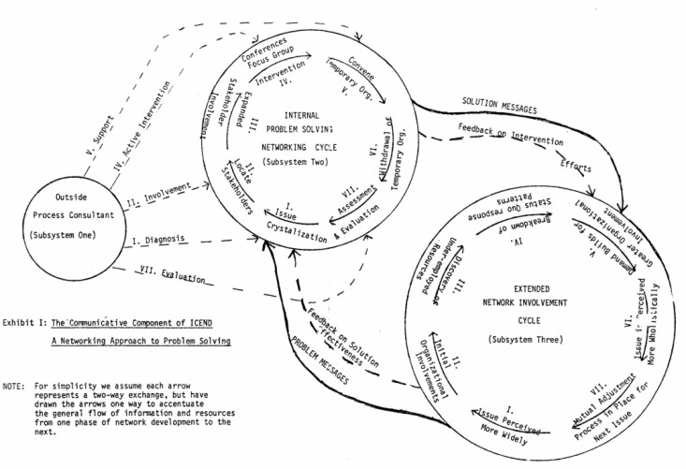
Figure 4: Boje’s ICEND Consulting Model (Boje, 1979, 1981, 1982)

Water technology-in-the-making can proceed in an ICEND intervention, but it needs something more to be a paradigm shift from Carboniferous Capitalism to Ecologically Balance Post-Capitalism. I believe what is missing is water aliveness and posthumanist ethics. Humanist ethics is humancentric, the human standpoint on everything. Posthumanist ethics recognizes the right of all species to water and other life-giving elements. For me, what is crucial to understand is the difference between Mikhail Bakhtin’s (1993) ‘special answerability’ and ‘moral answerability’.
Bakhtin’s (1993: 2) book is derived from his notebooks written between 1919 and 1921. Bakhtin tells us ‘Culture’-World and ‘Life’-World is not the same and constitutes two-faced Janus, facing in different directions, with no unitary plane between them for communication. Culture-World looks backward, at the past, that never was, while Life-World looks to the once-occurrent events of Being, here and now, unfolding. I think Janus has a fourth face, I call antenarrative, looking to the ‘World of Future’.
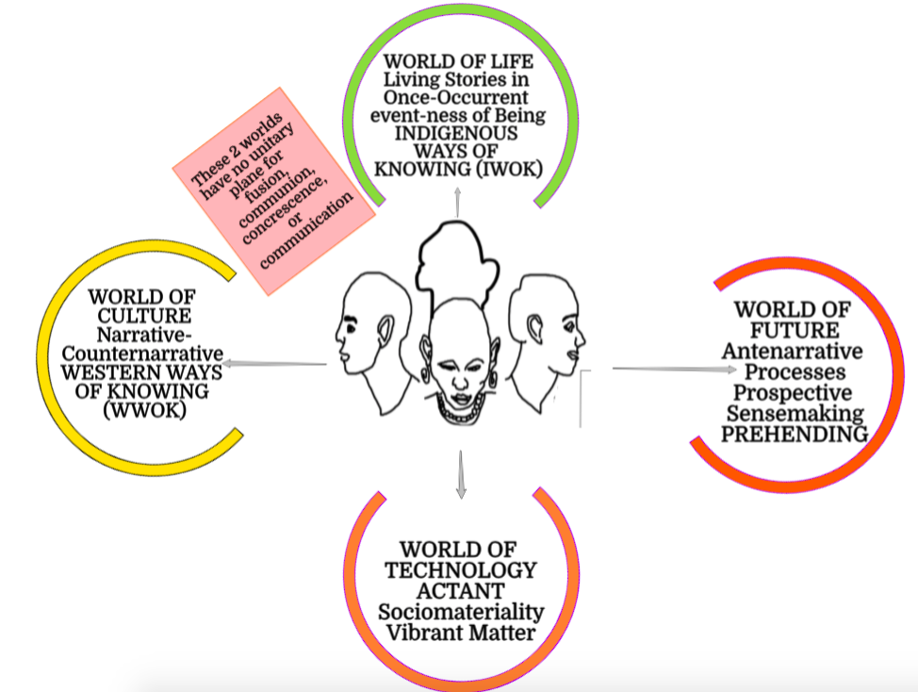
Figure 5: The Four-Fold Faces and Worlds of Storytelling (drawing by D. M. Boje)

In the figure I have drawn in the barrier between World of Culture and World of Life that Bakhtin has acknowledged where there is no possible communication, fusion, or concresence. There is something in the recycling of things, putting those things into the being-actant-things that point to the relation between aesthetic-narrative, and living-story. Aesthetics rules the decoration of the three Business College buildings, and it’s bystander ‘special answerability’, of people looking on while recyclables are contaminated with trashy material things. ‘Moral answerability’, by contrast, runs through the living story ‘Life World’ in which context matters to living story.
At issue is discovering a sociomaterial water process intervention that enables the emergence of water sharing ethical behavior between human and non-human actors. This paradigm shift is away from what I call G₃: Growthmania, Greed, and Gluttony of ‘Water Capitalism’ to a Balanced Water Ecology of Aliveness’ (Boje, in press; Boje, 2018). Water storytelling is a paradigm shift from linear narrative (beginning-middle-end) to nonlinear dynamic relational ontology processes. Posthumanist Water Ecology needs to take ontological priority over a Water Capitalism narrative-counternarrative dialectic deadlock. We must shift our attention from G₃ instrumentalist ethics to the ethics of moral answerability to find our path to Posthumanist Water Ecology that averts the apocalypse consequences of Sixth Extinction (Boje, in press).
A water history of the planet needs to be written in order to avert the water lifeboats for the rich that will occur if Water Capitalism and Water Politics maintain its death grip on our future. In New Mexico, for example, water rights are a commodity more valuable that land sold without those water rights. I heard several students in our ‘leadership in society’ course, who grew up in Future Farmers of America, say: ‘water is a family farm heritage, passed generation-to-generation’, and ‘you just don’t sell your water heritage at any price.’ We need to develop a ‘relational process ontology’ (a way of being and doing) that applies to Posthumanist Water Ecology. Certainly this one arise out of Goal 16: Peace and Justice by Strong Institutions caught up in what Smith (2016) describes as the three pillars of white supremacy we reviewed in Part I of this essay.
The WWOK-IWOK narrative-counternarrative dialectic within water storytelling is gridlocked in water politics, and does not get us to a new water-sharing paradigm of Posthumanist Water Ecology Aliveness. Water is life, not a dead commodity for Water Capitalism market speculation. Water has to become a living actor, and agentive in the problem-solving ICEND intervention in ways the new water paradigm can enable water innovativeness while achieving Ecologically Balance Posthumanism.

Further Reading
Bakhtin, M. M. (1993). Toward a Philosophy of the Act. Written as unpublished notebooks written between 1919–1921, first published in the USSR in 1986 with the title K filosofii postupka; 1993 English V. Liapunov, Trans.; V. Liapunov & M. Holquist, Eds.). Austin, TX: University of Texas Press.
Boje, D. M. (1979). "The Change Agent as Revolutionary: Activist Interventions into Inter organizational Networks," Transorganizational Development Session of the Academy of Management Meetings, Atlanta, Georgia, August.

Boje, D. M. (1981). "Organization Lore in Transorganizational Praxis," Invited Paper for the Academy of Folklore Meetings," in San Antonio, Texas, October 22-24.

Boje, D. M. (1982). "A Networking approach to the problem of securing Hi Tech jobs for unemployed minority autoworkers" This paper contends my first write up of ICEND model detailed in Table 11 including 3 subsystems. December 31.

Boje, D. M. and Wolfe, T. (1989). "Transorganizational Development: Contributions to Theory and Practice," 733-753 In Leavitt, H., Pondy, L. R., and Boje, D. M., Readings in Managerial Psychology, Chicago Press, Third Edition.

Boje, D. M. (1997) "Radical transorganizational development theory and praxis: From Weber and Durkheim to Postmodern." Research Monograph (September).

Boje, D. M. (1999a) "Holon and Transorganization Theory" {September 30} (press here)

Boje, D. M. "(1999b). Transorganization Development and the Death of Organization Development {October 3} (Press here).

Boje, D. M. (1999c). "Who Rules Large System Transorganizational Development (TD) Consulting?" {October 6} (press here).

Boje, D. M. (1999d). "Storytelling and the Collective Dynamics of Transorganizational Networking" {October 7} (press here).

Boje, D. M. (1999e)"Chaos and Complexity in Supply Chain Transorganizational Development Networking" {October 9} (press here).
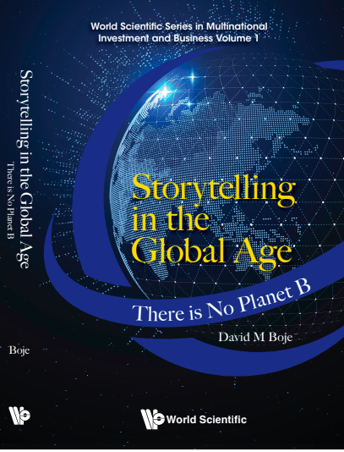
Boje, David M. (in press). Storytelling in the Global Age: There is no planet B. Hackensack, NJ: World Scientific Publishing Pte. Ltd.

Boje, David M. (2018). True Storytelling of Water. Proceedings of 8th annual Quantum Storytelling Conference, Las Cruces New Mexico, Dec 12 to 14. Accessed Nov 5 2018 at http://davidboje.com/388/2018%20storytelling%20conference%20BOJE%20__%20True%20Storytelling%20of%20New%20Mexico%20Water.docx
Cajete, Gregory. (1999). People’s Ecology: Explorations in Sustainable Living. Santa Fe, NM: Clear Light Publishers.
Cajete, Gregory. (2000). Native science: Natural laws of interdependence. Santa Fe, NM: Clear Light Publishers.
Cajete, Gregory. (2015). Indigenous Community: Rekindling the Teachings of he Seventh Fire. St. Paul, MN: Living Justice Press.
Culbert, Samuel A., James Max Elden, Will McWhinney, Warren Schmidt & Bob Tannenbaum. "Trans-organizational praxis: A search beyond organizational development," International Associations, XXIV (10, October). 1972. Still an excellent piece. This was the first piece I read that got me started in TD.
Deloria, Vine Jr.; Wildcat, Daniel R. (2001). Power and Place: Indian Education in America. Golden, CO: Fulcrum Resources.
Hawkesworth, M. (2010). From constitutive outside to the politics of extinction: Critical race theory, feminist theory, and political theory. Political Research Quarterly, 63(3), 686-696.

Hoskins, Kawehau; Jones, Alison (2017 Eds.). Critical Conversations in Kaupapa Māori. Wellington, Aotearoa New Zealand: Huia Publishers.
Humphries, Maria. (2016). Weaving IWOK into the sotrying of business, ethics, and the busy-ness of being human. Pp. 225-238 in Grace Ann Rosile (ed.) Tribal Wisdom for Business Ethics. Bingley, UK: Emerald Group Publishing Limited.
Little Bear, Leroy. (2000). Foreword. Pp. ix-xii in Cajete, Gregory (ed.) Native science: Natural laws of interdependence. Santa Fe, NM: Clear Light Publishers.
McCoy, D. L., & Rodricks, D. J. (2015). Critical race theory in higher education: 20 years of theoretical and research innovations. ASHE Higher Education Report, 41(3), 1-117. Accessed Nov 4 2018 at https://static1.squarespace.com/static/54c9087fe4b0b5cc4d84974d/t/5772127ed2b85749fa66bce7/1467093631847/9777F4C0-FE28-48F0-95F7-F6FFD7D7BB3C+copy.pdf

Matsuda, M. J., Lawrence, C. R., III, Delgado, R., & Crenshaw, K. W. (1993). Word that wound: Critical race theory, assaultive speech, and the first amendment. Boulder, CO: Westview.

Mumford, Lewis. (1934). Technics and Civilization. Accessed Nov 5, 2018 at https://monoskop.org/images/f/fa/Mumford_Lewis_Technics_and_Civilization.pdf
Pepion, Donald D. (2016). Indigenous Ways of Knowing and Quantum Science for Business Ethics. Pp. 17-22 in in Grace Ann Rosile (ed.) Tribal Wisdom for Business Ethics. Bingley, UK: Emerald Group Publishing Limited.
Rosile, Grace Ann. (2016). Tribal Wisdom for Business Ethics. Bingley, UK: Emerald Group Publishing Limited.
Smith, Andrea. (2016). Three pillars of White Supremacy by Andrea Smith, pp. 66-73 in Dickinson, Torry D. and Schaeffer, Robert K. (Eds.) Transformations: Feminist Pathways to Global Change: An Analytical Anthology. First published 2008 by Paradigm Publishers. 2016 NY: Routledge. Accessed Nov 4 2018 at https://www.pym.org/annual-sessions/wp-content/uploads/sites/7/2017/06/Smith_Heteropatriarchy_3_Pillars_of_White_Supremacy.pdf
Smith, Graham Hingangaroa. (2003). ‘Indigenous struggle for the transformation of education and schooling.’ Keynote address presented to the Alaskan Federation of Natives (AFN) Convention, Anchorage, Alaska. Accessed Mar 27 2018 at http://www.ankn.uaf.edu/curriculum/Articles/GrahamSmith/index.html
Smith, Graham Hingangaroa. (2017). Kaupapa Māori Theory: Indigenous transforming of education. Pp. 79-94 in in Te Kawehau Hoskins and Alison Jones (Eds.) Critical Conversations in Kaupapa Māori. Wellington, Aotearoa, New Zealand: Huia Publishers.
Smith, Linda Tuhiwai. (1999). Decolonizing Methodologies: Research and Indigenous Peoples. London: Zed Books.
Smith, Linda Tuhiwai. (2008). Decolonizing Methodologies: Research and Indigenous Peoples. NY: Palgrave (St. Martin’s Press, LLC).

Accessed Nov 5 2018 at https://en.wikipedia.org/wiki/Water_spirit
Waterspirit accessed Nov 5 2018 at https://www.waterspirit.org
Huffington Post, acced Nov 4 2018 at https://www.huffingtonpost.com/antonio-moore/black-mass-incarceration-statistics_b_6682564.html
http://www.narrativemedicine.org/wp-content/uploads/2017/04/Smith_%20Heteropatriarchy.pdf
“Anthropogenic compounds that have been detected in groundwater of the basin include volatile organic compounds (VOCs) (particularly chlorinated solvents and petroleum hydrocarbons) and pesticides (particularly herbicides with urban uses). Most detections of these compounds have been in monitoring wells in or near the Rio Grande inner valley—an area that is intrinsically susceptible to groundwater contamination because of the presence of recharge and depths to groundwater generally less than about 30 ft (Anderholm, 1987)—and the detected concentrations have been below maximum concentrations specified in the USEPA’s water-quality standards. In some cases, however, VOC detections near known chemical releases have resulted in the closure of private domestic wells and public-supply wells” (U.S. Environmental Protection Agency, 2006). Accessed Oct 15 2018 at https://pubs.usgs.gov/pp/1781/pdf/pp1781_section11.pdf

